SUPERPOSITION THEOREM – A/H/P 2

# PROBLEM 1- DC

1. **All sources considered**

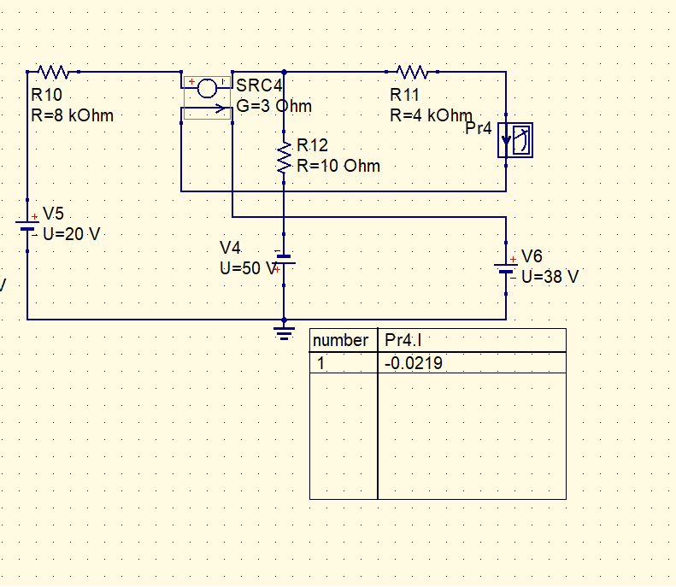

1. **20V source**

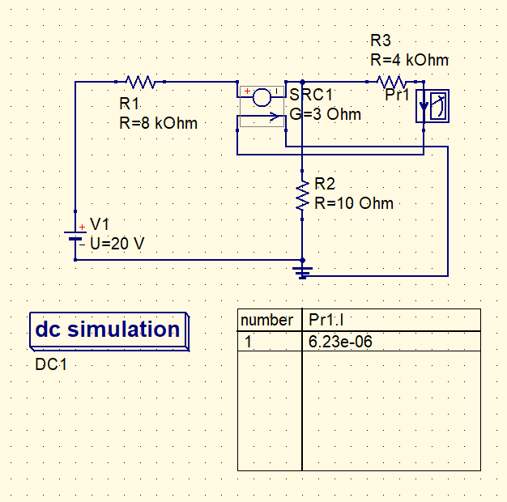

1. **50V source**

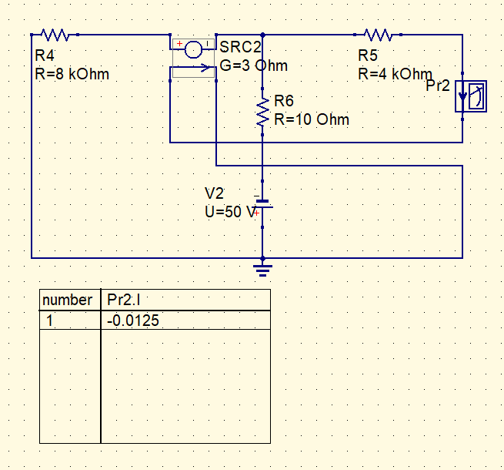

1. **38V source**

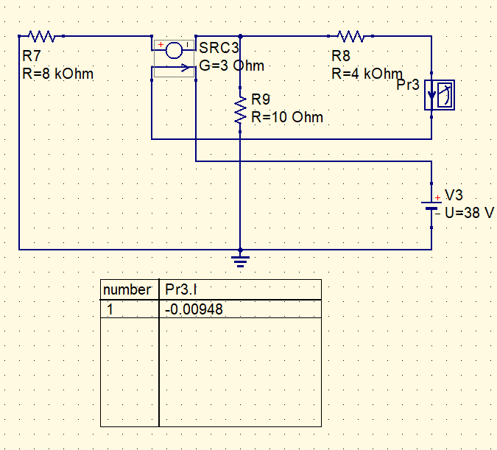

# **2. PROBLEM 2- AC**

1. **All sources considered**

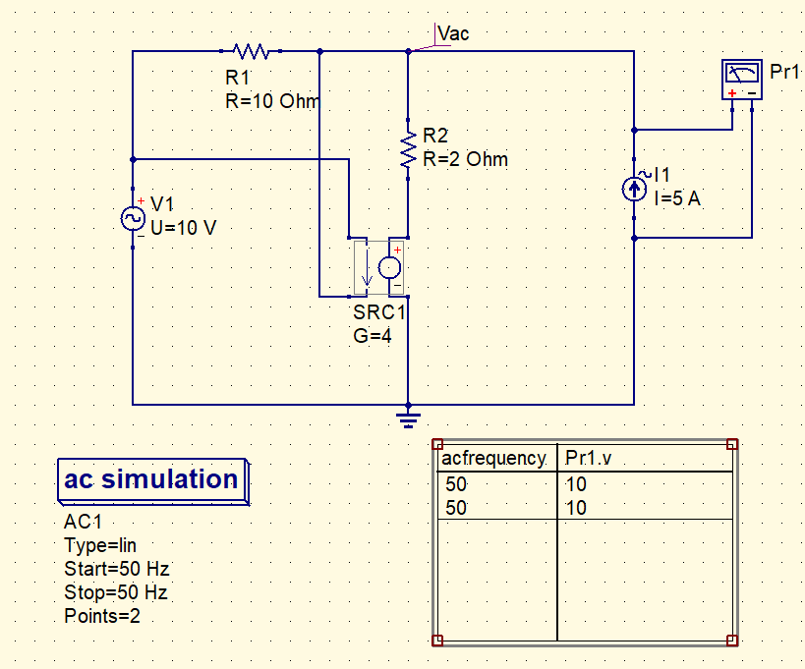

1. **10V source**

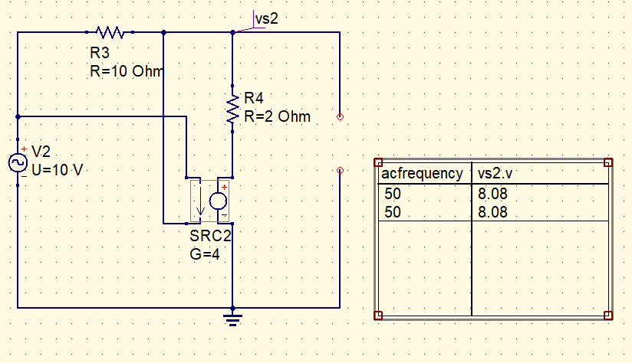

1. **5A source**

